Window to Bolivia

Providing A Glimpse Into Another Part Of Our World
Bolivian Youth Ministries Jonathan and Linda Baker
** March 2007 **

We know love by this, that He laid down His life for us; and we ought to lay down our lives for the brethren.
I John 3:16

PRAYER

* Pray that the Lord would lift up excellent Christian workers here in Cochabamba. There is a desperate need to find workers who want to serve in ministry.
* Please pray that God would keep His hand on our growing family. There have been some definite attacks and challenges on our children. The transition for them is never easy.
* Fall is here and Winter is coming (May). It’s always a difficult sickness time for the 26 girls and many of the adults. Please pray for health.

PRAISE

* Over and over again we will continue to thank God for His provision of finances for operating the homes here. We have 30 full time and 6 part time mouths to feed, bodies to clothe and hearts to fill.
* The past few months have been rather politically unsettling. God has graced us with living in a fairly quiet area and we have never felt threatened.
* Lastly through food and cooking gas shortages, we have never been short of what we need.

“So Others May Live”

Last week I finally saw a movie I’ve been wanting to see for some time: The Guardian. I can’t really recommend the movie (language, sexual implications, Etc.) but I can say that I see some definite parallels to our service to God.

I think it was God that coined the phrase “So Others May Live” about 6000 years ago when He created the plan for man’s salvation. It was God that implemented it when He sent His Son to die 2000 years ago. The USCG picked up on the idea and we, as Christians, should also.

Are we ready to lay down our lives for God and others? Are we ready to commit ourselves to His Two Commandments? But how do we know what we are to do? Who do we serve? We can’t give up our lives for everyone can we?

-- “When you can’t save them all, how do you choose?”

-- “I take the first one I come to or the weakest one in the group, and
then I swim as fast and as hard as I can - for as long as I can.“

I don’t follow the Gospel according to Kevin Costner, but he does have a point. As our brother Keith once said, “Go to the hungry ones and fill them with His bread…”

First and foremost we must seek God’s will and what He has set out for us (Romans 12:1&2). Next we must serve those that he sets in our path. We have got to be ready to stop our daily routine and see the drowning person in front of us. The weak and the hungry are top priority.

Take the challenge from the Lord and get ready to swim fast and hard. Pull them out of the drink and bring them to the saving Grace of God.

In Case You Missed It.

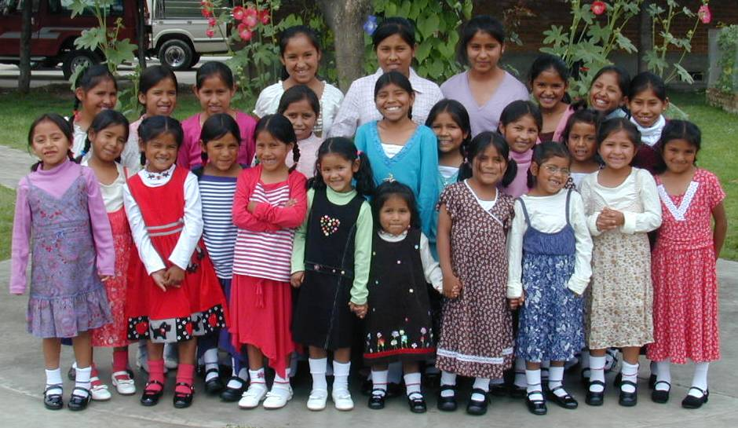

Christmas day. Christmas Dresses.
¡ MUSIC !
Go to the hungry ones and fill them with His bread,
They'll leave their darkness as you shine the light He shed,
Point to His promises, believe in all He said,
And His joy will be manifest in you,
And the lost will be found as He works through you.
Out on the highways, there's so many passing by,
Step out in boldness and watch the family multiply,
Pray up some miracles, lets open up the sky,
And His joy will be manifest to you,
And the lost will be found by the things you do.
Oh don't you know that Jesus loves you,
So let's go and spread His word,
Redeem the time while there's still time,
Let's share the call we heard, lets share the call we heard.
Is your house open to let strangers enter there,
Give to the least of them, show them someone cares,
And you may be entertaining angels unaware,
And His joy will be manifest to you,
And the lost may be found as He works through you,
And His joy will be manifest in you,
And the lost, they'll be found by the things you do.

Keith Green

Misión Niñez Boliviana
Cajón 3471
Cochabamba
Bolivia

BYMinistries.org

BYM@BYMinistries.org

Please look at our website for lots of good pix and information.
Email us any time!
“May I have the grace to live above every human motive; simply with God and to God.”

Jonathan & Linda Baker
Rosa and Joanna
(Bolivia)

Ryan
(Kenya)

Joshua and Zachary
(US)

Kyle, Diana, Todd & Peter
(US)
26987 Fern Ridge Road
Sweet Home, OR 97386

Bolivian Youth Ministries
Sweet Home Community Chapel

42250 Ames Creek Road
Sweet Home, OR 97386

